Lesson 6 – From Designer to Code

Class_Globals
Variables and Subs
Passing Values to Code
Events
Attributes

What students should know
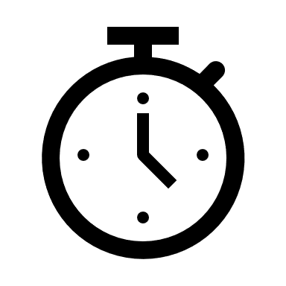2h

Designing the app's appearance in Designer is the first step in the manufacturing stages. Often new developers turn to it to redesign, correct, or add individual information.
When the screen is ready the developer goes to the next stage of programming the functions. That is, everything that elements included in the design to gain functionality. In other words, text boxes can record data, buttons can activate functions, lists can display data, etc.

Class_Globals
At the beginning of the code on tab B4XMainPage there is a set of variable declarations between Sub Class_Globals and End Sub.
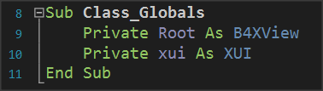
As it has already been said in 3rd Lesson Sub is a set of code that performs a specific operation. The operation of the Class_Globals is to collect the declarations of variables that we want to be known throughout the code of the tab B4XMainPage, i.e. in each subprogram.
Picture 2 Sub Class_Globals
In addition, if a variable statement starts with the public it will be available from other program "tabs".

A deeper look at the use of variables.
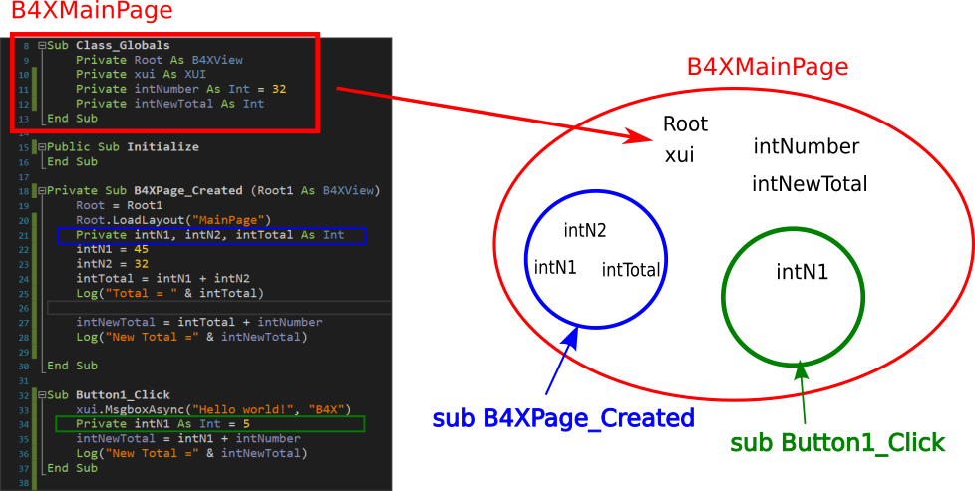
In the following code you see three subprograms
Picture Variables and Range

The intNumber, intNewTotal, Root, and xui variables declared within Class_Globals "live" within Module B4 XMainPage.
On the contrary, variables intN1, intN2, intTotal 'live' within the sub-program B4XPage_Created and for this reason No another subprogram may use them. At the same time, the variable intN1 who lives in the Button1_Click is not the same with the one in B4XPage_Created, both has its own memory space, and both can have the same name.
Teachers tip
The use and range of variables is something that confuses new developers. Depending on your class, it is recommended to make examples of familiarity in their use.

Passing Values to Code
The screen you have already prepared contains objects that you must declare as variables in Class _ Globals to use in the program.
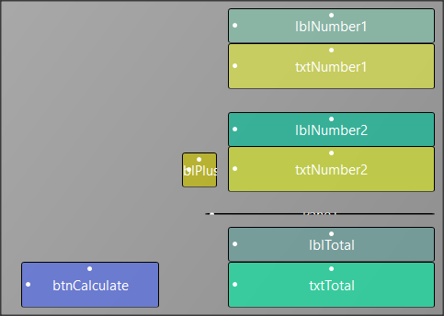
In the example, in the previous lesson, some of the objects on the screen do not have to be included in the code.
Picture Example 1 Designer View
So, all "labels" items in this application do not have to be managed by code as well as the pane element. While button and textFields must be added to schedule functions on them.
There are two ways to insert your objects into the code. The first is easily done through the designer with the following functions:
From the Tools menu select Generate Members
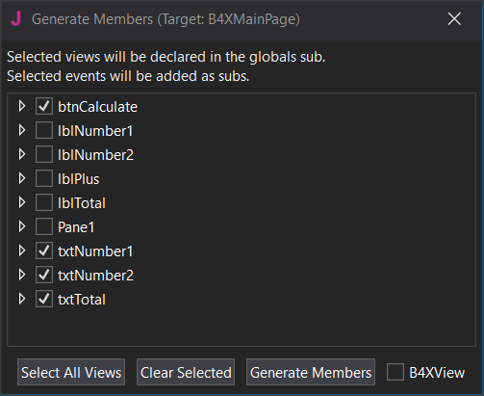
In Screen Generate Members just click on objects
Picture 5 Generate Members
- btnCalculate
- txtNumber1
- txtNumber2
- txtTotal
and then click Generate Members.
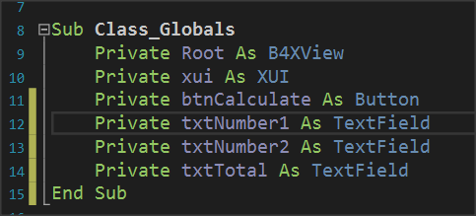
Picture 6 Class_Globals
Your code in the Class_Globals subprogram will be updated automatically with the variables.

Remember
Each object we import is of a certain type as well as the types of variables.

The second input solution is to write the variables yourself, paying attention so that the names of the objects on your screen are the same as those you write as a variable.

Events
After you have declared the variables of the objects, the final stage is to enable the functions of the form.
This depends on how you've decided that each app works. In the example with the two numbers there is a button called Calculate and it is what will activate the addition as well as the appearance of the result on our screen.
The operation is triggered by a process called "Event. The programmer must detect the event of pressing the key Calculate and when this is done then do the relevant calculations and display the result.
Remember
There are hundreds of different events happening in one application; the developer determines how the program will react to each of them.

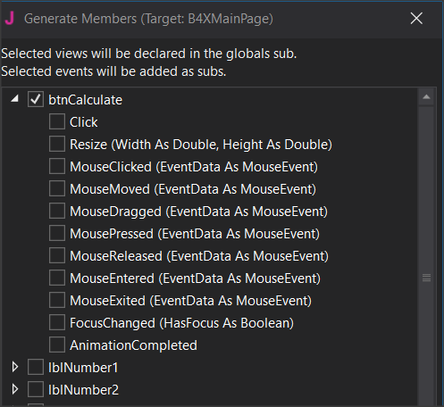
The detection of the event is easy and you just need to create a new subprogram that has the name of the event. This can be done at the same time as the declaration of the variables of our objects through the Designer.
Picture 7 Setting Event
Open its list btnCalculate and several Events we’ll be available to choose. Just click on "Click” and "Generate Members”.
The subprogram for the btnCalculate_Click event has already appeared. Within it you will write the program code to complete.
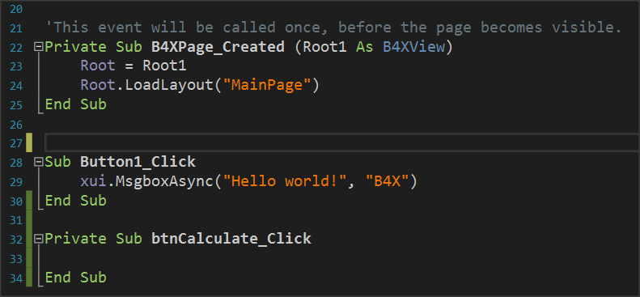
Picture 8 The Click Event

Writing code in Event
Within an Event subprogram, all the functions associated with it are usually performed.
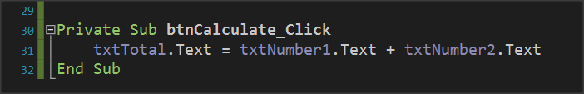
Picture 9 Calculating textFields
Essentially both are achieved with a single command. This is the command of Picture 9 Calculating textFields follows:
The content of textField txtTotal is equal to the contents of txtNumer1 and txtNumber2.

Properties
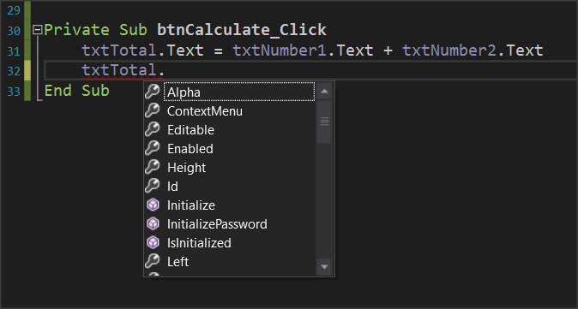
Each object you insert into your code has a number of different properties. For example properties can be the color, size, location content as they have been Described and in the previous lesson. These properties can provide information or change display issues. For example, the property txtNumber1.text provides information on the content of the object txtNumber1 or can set a value as content depending on how you use the. This information is type string.
Picture 10 Object Properties
Remember
You can do operations with string contents when they describe numbers.

Let us now assume that we want to create a new function in the example where another key clears the form to write new numbers. The functions you will perform are as follows:
- Open Designer and add a new button named e.g. btnClear.
- Set it as a variable in Class_Global.
- Enter the event btnClear_Click.
- Set the text properties of txtNumber1, txtNumber2, txtTotal to "".

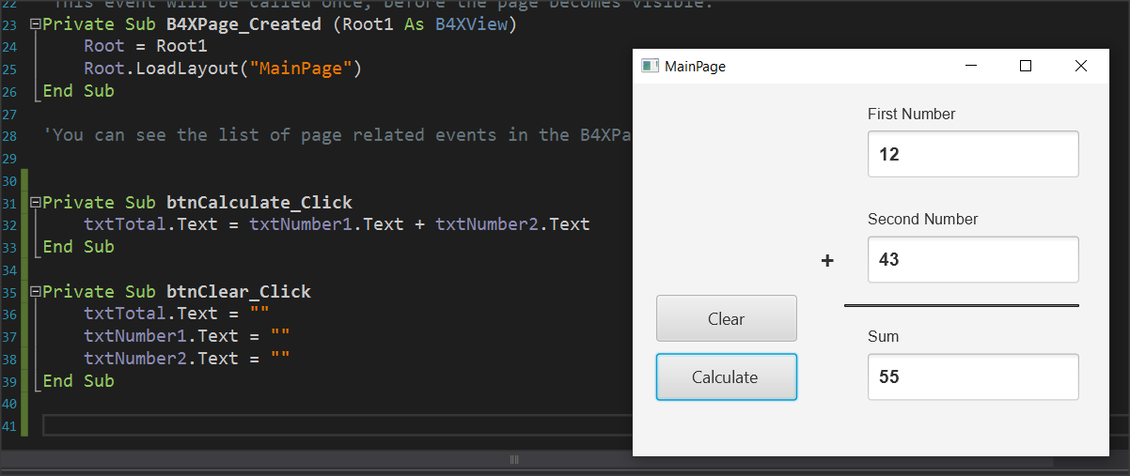
Picture 11 Clear Button and Code
When you press clear, the form will clear.

Exercises
1. Extend the example to perform the four operations: Add, subtract, multiply, and divide at the click of an appropriate button. Add the appropriate objects to the designer and then complete the code.
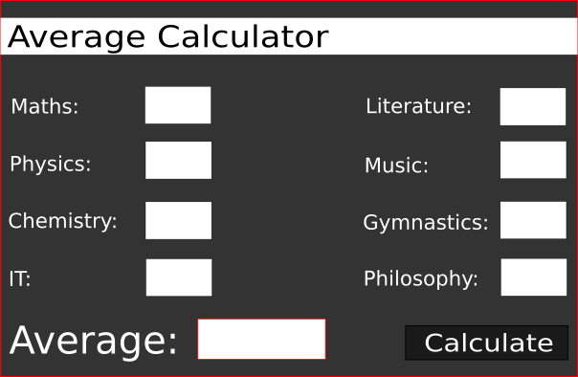
2. In exercise 2 of the previous course continue and complete the application by activating its functions.

Take care that the numbers in lessons must be between 0-100. If not, you should show an error message.

